Chapter 14, Problem 83.

The op amp circuit in Fig. 14.100 is to be magnitude-scaled by 100 and frequency-scaled by 10⁵. Find the resulting element values.

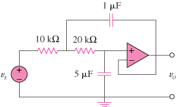

Figure 14.100
For Prob. 14.83.

